use DBMS ;
show databases;

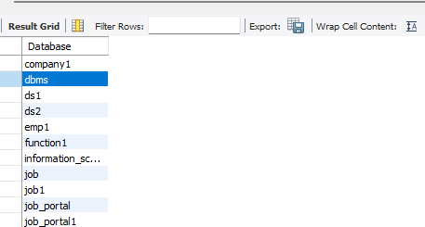
Create a table
CREATE TABLE employees(emp_id INT,emp_name VARCHAR(100),city VARCHAR(50));
ALTER TABLE employees ADD department VARCHAR(50);
select*from employees;

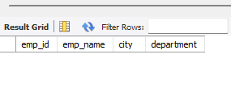

ALTER TABLE employees RENAME COLUMN emp_name TO full_name;
select*from employees;

